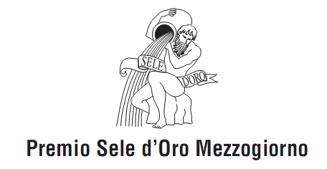
2022 SELE D’ORO MEZZOGIORNO PRIZE
APPLICATION

The undersigned, Name Surname
Place of birth Country _________
Date of birth ___ / ___ / _____
Address of permanent residence _______________________________________________
Phone Mobile phone
Preferred e-mail address for correspondence ____________________________

APPLY
For 2022 SELE D’ORO MEZZOGIORNO PRIZE, for the following section

LITERARY ESSAYS
Eu EUROMED (for unpublished essays)
JOURNALISM (in memory of journalist Michele Tito)
BONA PRAXIS (focusing on development projects)
BONA PRAXIS YOUNG (focusing on the development projects being promoted by youth
between 18 and 35 years old, in memory of Professor Mario Raffa)

Attachments:
________________________________________________________________________________________________________________________________________________________________________________________________________________________________________________________________________________________________________________________________________________
Date Signature

“In compliance with the Italian Legislative Decree no. 196 issued on 30 June 2003 and with the EU 2016/679 Regulation (GDPR), I hereby authorize the recipient of the document herein to use and process my personal details for the purpose of this Call for Proposal and I confirm that I have been informed of my rights in accordance to the aforementioned documents.”

Date Signature

